ROUTE: RAGLAN ROAD
START: 18:30

South down Alma Rd to:
L Holmesdale Rd
L Warren Rd
L Oak Rd
R Wray Park Rd
R St David’s Close (in & out)
L Wray Park Rd
R Brightlands Rd
R Fairford Cl (in & out)
R Brightlands Rd
L Raglan Rd
R Huntersfield Cl (in & out)
L Raglan Rd
R lders Rd
R Yardley Cl (in & out)
L Alders Rd
R Wray Park Rd
SOUP STOP
R Alma Rd (collect from
Sheridan Dr & Beverley Hts)
L Raglan Rd
R Friths Dr (in & out)
R Raglan Rd
L Reigate Hill
L Merrywood Park (in & out)
L Reigate Hill
R Brokes Rd
R Brokes Cres & Albany Cl (in & out)
R Brokes Rd
L Park Hall Rd (in & out)
R Brokes Rd
R Reigate Hill
L Birkheads Rd to Finish.

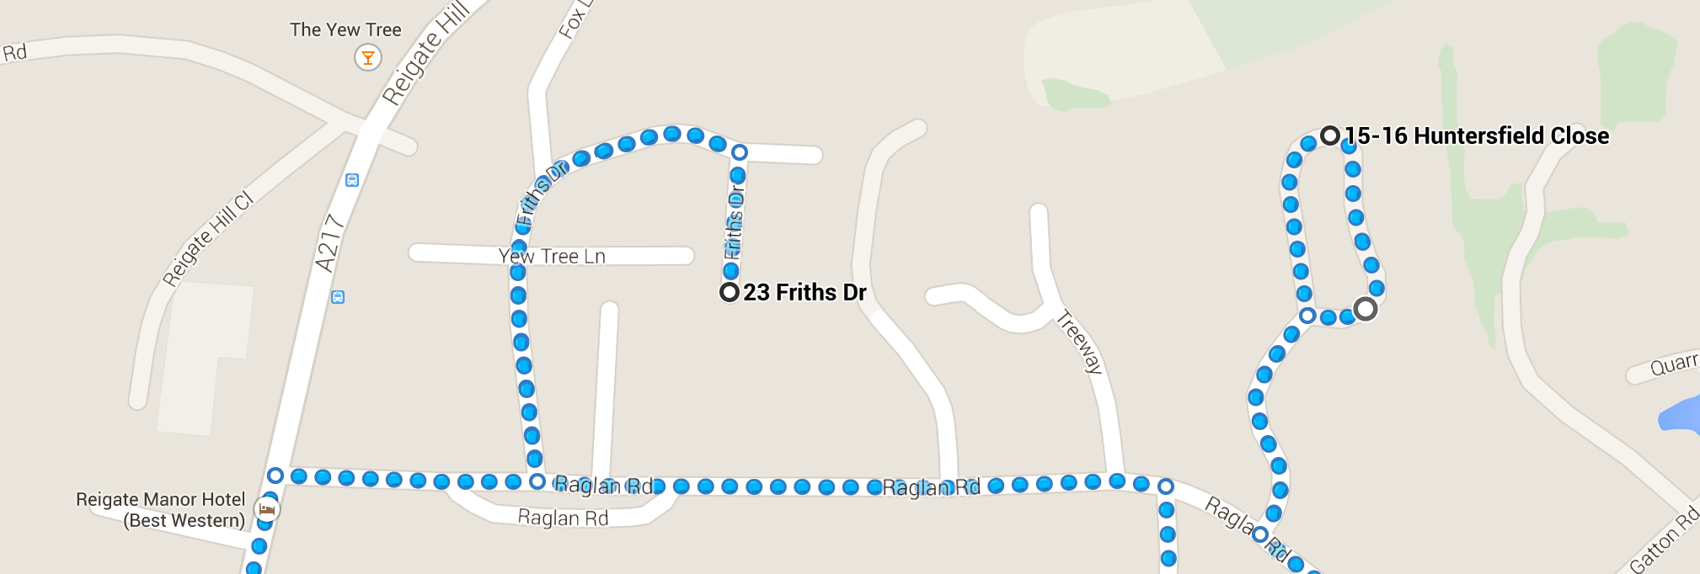

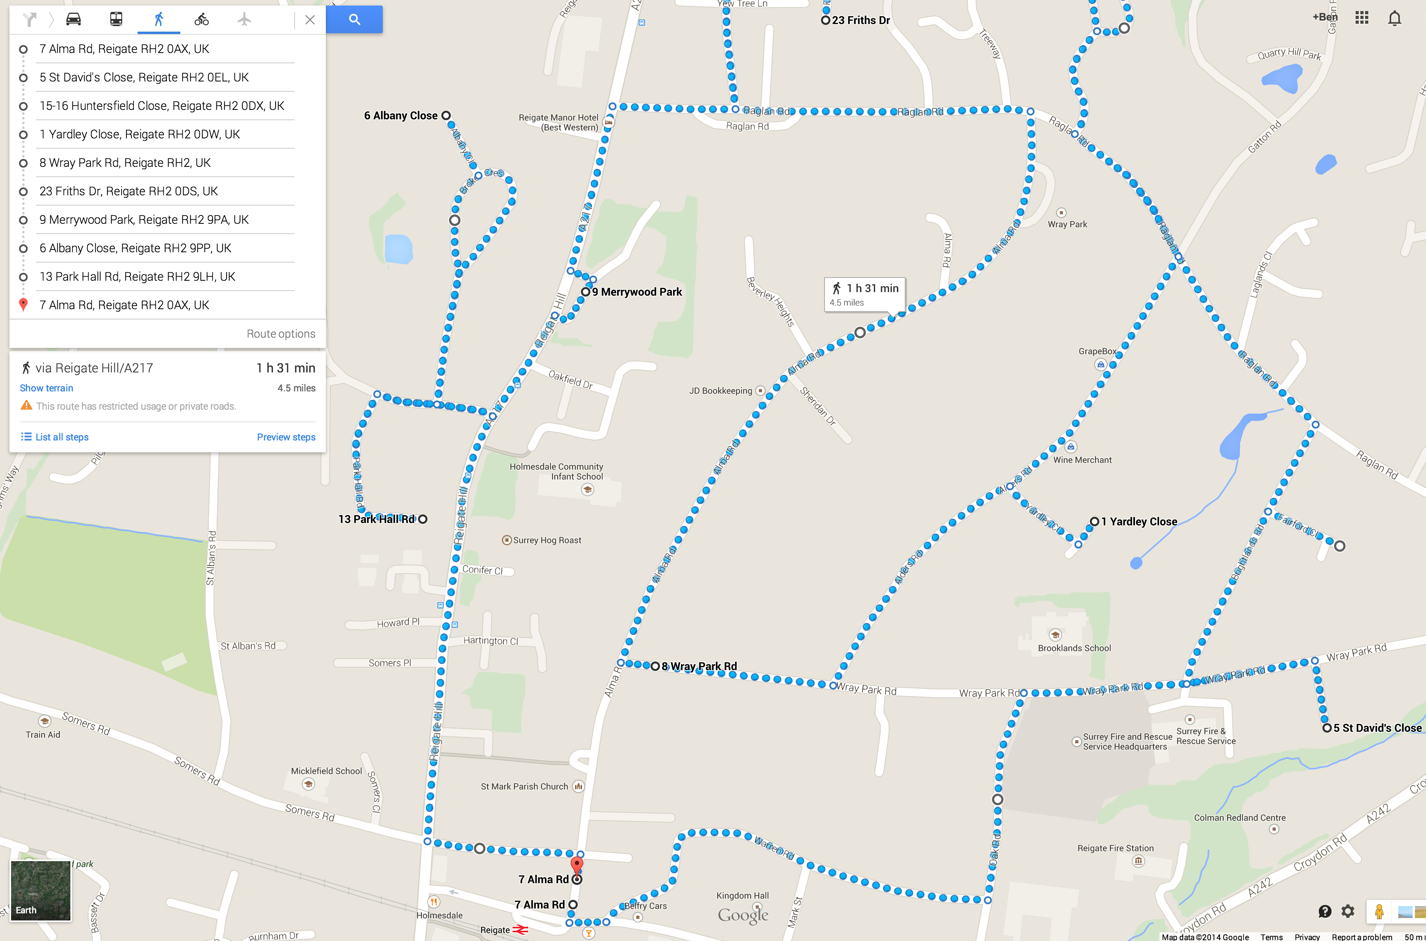

SOUP

START & FINISH
(Postcode: RH2 0AX)

Google Map Version (1 of 2) (Full Map: https://goo.gl/maps/GKXfe Map with Directions: https://goo.gl/maps/hGmgB)
ROUTE: RAGLAN ROAD
START: 18:30

South down Alma Rd to:
L Holmesdale Rd
L Warren Rd
L Oak Rd
R Wray Park Rd
R St David’s Close (in & out)
L Wray Park Rd
R Brightlands Rd
R Fairford Cl (in & out)
R Brightlands Rd
L Raglan Rd
R Huntersfield Cl (in & out)
L Raglan Rd
R lders Rd
R Yardley Cl (in & out)
L Alders Rd
R Wray Park Rd
SOUP STOP
R Alma Rd (collect from
Sheridan Dr & Beverley Hts)
L Raglan Rd
R Friths Dr (in & out)
R Raglan Rd
L Reigate Hill
L Merrywood Park (in & out)
L Reigate Hill
R Brokes Rd
R Brokes Cres & Albany Close (in & out)
R Brokes Rd
L Park Hall Rd (in & out)
R Brokes Rd
R Reigate Hill
L Birkheads Rd to Finish.

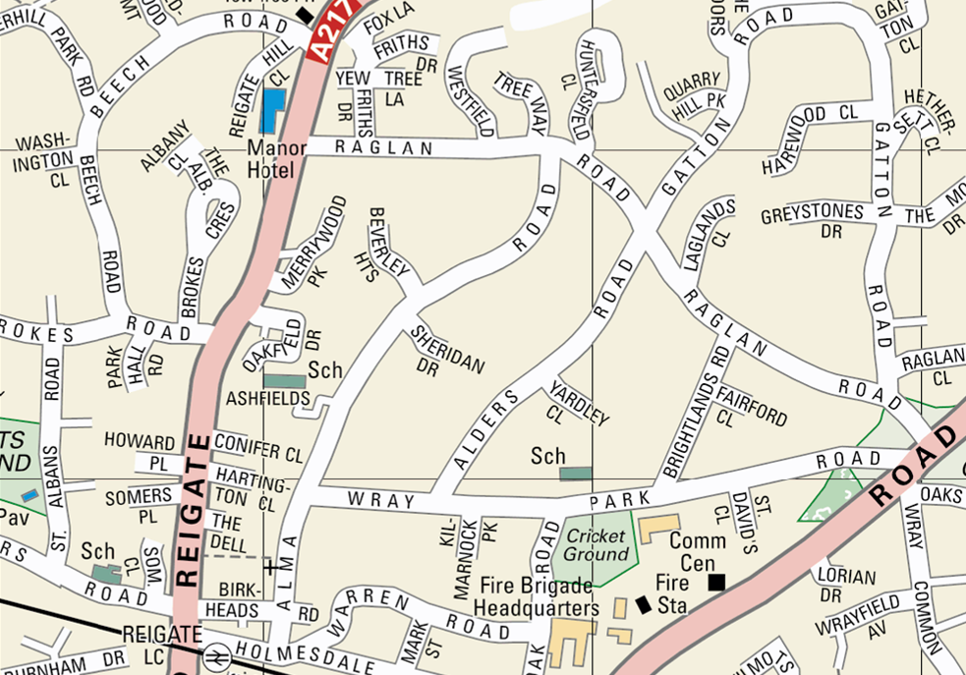
Ordinance Survey Map Version (2 of 2)

